Type the Title here using Upper and Lower Case in 12 Points Arial, Bold, Centered

1st author's first name and family name^{1, 2}, 2nd author's first name and family name², etc. the presenting author should be underlined
¹author's affiliation, city, country (10 points Arial, italics, centered)
²author's affiliation, city, country

Enter the abstract text (use font type Arial 10 points with single spaced lines) here making certain it is in a two-column format. Please use this template, erase the sample texts and fill in your text.

Page margins should be 2,5 cm for top, left, right and bottom margins. Abstract information must not appear on or outside the margins. All information must fit on one page. Abstracts must be RTF or DOC (Microsoft Word) document formatted to A4 (21 cm x 29,7 cm). File size is limited to 2 Megabyte.

Abstract text is justified (therefore aligned along both the left and right margin of the column); paragraphs are not indented, only separated by one blank line. Paragraph headers, if needed, should be written in bold (align left). Abstracts should be written in English. Tables or images should be used when necessary to substantiate results and should be pasted into the abstract template form. Ensure that they are within the printable area of the page.

Table and Images Captions: Image captions should appear aligned left under the corresponding figure and set in 10 points Arial. Table captions should appear aligned left above the corresponding table and be set in 10 points Arial. These items should appear as close as possible to where they are cited.

Caption table
Table | Table | Table | Table | Table
Table | Table | Table | Table | Table
Table | Table | Table | Table | Table

All images must be in grey scale, please do not send color images since their conversion into grey scale might not provide the required image quality. They should be checked using a high-quality black-and-white laser printer. We suggest you print your manuscript before submission.

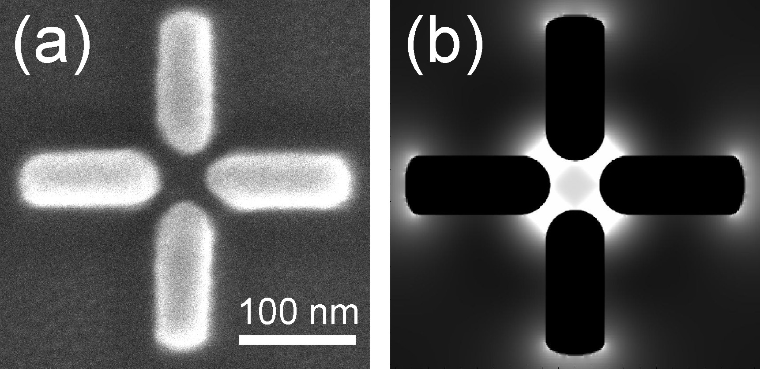
Caption image

All abstracts must be submitted via email to the address plasmonica2014@gmail.com by April 14th, 2014.
The abstract in .doc or .rtf format must be attached to the email and the preference for oral or poster presentation must be specified in the body of the message. You will receive an acknowledgment within three days after your submission.

References
References should appear at the end of the abstract in the order in which they are referenced in the body of the paper (style: Arial points 8 aligned left). Within the main text, references should be designated by a number in brackets [1], and they should be followed by a comma or period [2]. Two references cited at once should be included together [3,4], separated by a comma, while three or more consecutive references should be indicated by the bounding numbers and a dash [1–4].

[1] C. van Trigt, JOSA A 14, 741-755 (1997).
[2] David F. Edwards, in Handbook of optical constants of solids, E.D. Palik, ed. (Academic, Orlando, Fla. 1985).
[3] F. Ladouceur and J. D. Love, (Chapman & Hall, 1995), Chap. 8.
[4] Author(s), in Title of Proceeding, (Institute of Electrical and Electronics Engineers, New York, 1900), pp. 00-00.

