GLAM – Global Analysis on Manifolds
8-10 September 2008

Map of Rome (RM) – Dip. Me.Mo.Mat. at Via del Castro Laurenziano, 7A
Dip. G. Castelnuovo inside the Campus (Città universitaria)

Dip. Me.Mo.Mat.
Room 7, III level
Dip. G. Castenuovo
Room “Picone”
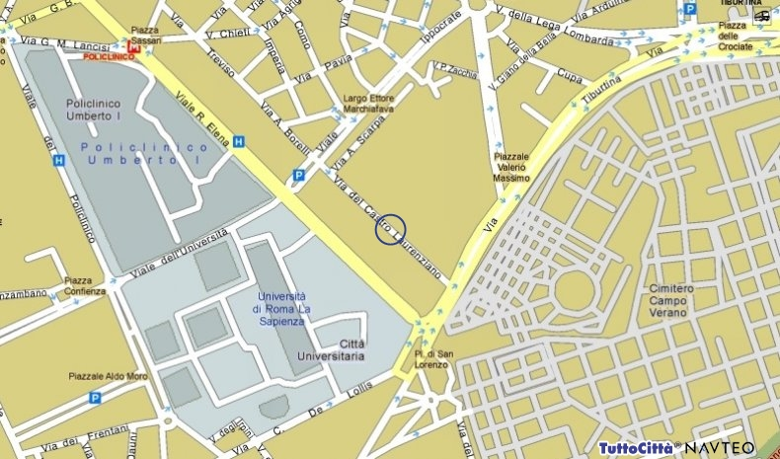
Inizio modulo

